Best Calculator Reference Manual

Version 3.2, May 2016

|  |  |
| --- | --- |
|  | |
|  |  |

# A Quick Tour of Best Calculator

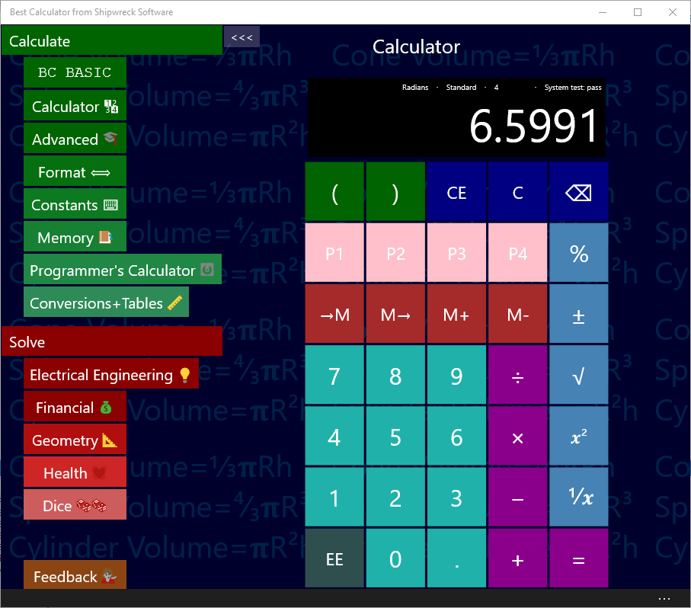

Use the menu on the left to pick a calculator page to use

Best Calculator has *Pages* (in green) for common calculations, *Solvers* (in red) for specialized calculations, and a Feedback button.

The most common pages that you’ll use in Best Calculator are the *Calculator* and *Advanced* pages. The Calculator page (shown in the example) is a simple calculator.

The Advanced page is where you can access the angle (trigonometry), logarithm and other advanced math functions. When you are on a wide screen, selecting Advanced will display both the advanced functions and the regular calculator.

The available pages are:

1. BC BASIC lets you program your calculator using the popular BASIC language.
   1. Algebra input lets you solve an equation quickly
   2. Sigma function lets you enter a Sigma (i=1 t N) function
   3. Library gives you access to all of your functions and a library of pre-made functions
2. Calculator is a common calculator
3. Advanced includes trigonometry and logarithm functions
4. Format lets you change how the results are displays
5. Constants lists common physical constants (like gravity)
6. Memory lets you save, recall and change memory slots
7. Programmer’s calculator is for hex and binary operations
8. Statistical calculator performs basic statistics on columns of numbers
9. Conversions and tables lets you convert between common units like converting liters to gallons. It also includes an ASCII table and Unicode lookup

The available solvers are

1. Electrical Engineering
   1. Voltage, Current and Resistance (V=IR)
   2. Resistors
   3. Resistor color code
   4. Capacitors
2. Financial
   1. CAGR (Compound Annual Growth Rate)
   2. Mortgage calculations
   3. WACC (Weighted average cost of capital)
3. Geometry
   1. Circles
   2. Right Triangles
   3. Slope
4. Health
   1. Ideal Heart Rate
   2. BMI (Body Mass Index) and BMI for Kids
   3. Pulse
5. Dice

The feedback page lets you give feedback about Best Calculator. We always include requested features in each new release!

**Are you using a Microsoft keyboard?**  You can program in the Best Calculator as the calculator program. See the Advanced Windows Features chapter for details.

**Back Button on the Phone**. The Back button lets you quickly switch between any two calculator pages or solvers. Once in a page, pressing back button once shows the menu. Pressing back button again switches you to the page you were at before.

For example, from the menu, go to the Calculator page. Tap the back button, and you are at the menu. Tap the Advanced page to go to the advanced page. Tap the Back button again to get to the menu, and once more to get to the Calculator page.

# Numbers and Common Calculations

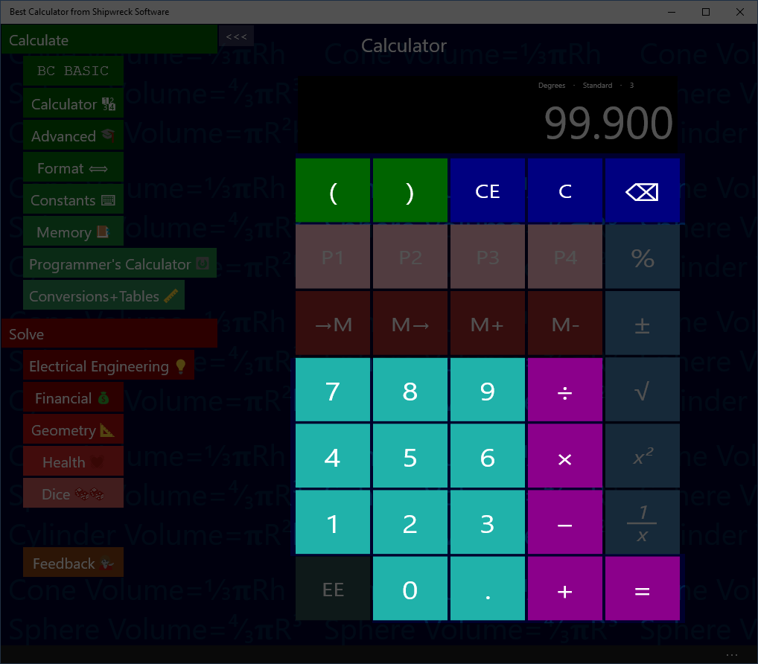

Addition, Subtraction, Multiplication, Division, Equals, Entering numbers

## Simple Arithmetic

A room is 15 feet by 20 feet. How many square feet of carpet is required to cover the floor?

Key in: 15 × 20 =  
*Answer:* 300

Pressing the = button gives the answer to the entered formula.

## Chain calculations

Press the = button again to repeat the last calculation (× 20)

Key in: 15 × 20 = =  
Answer: 6000

## Algebraic Entry and Parentheses

Calculations are performed as they are entered (“chain input”, or “Algebraic entry”)

Key in: 2 + 3 × 4 =  
*Answer:* 20

The 2 + 3 is calculated first and that result is multiplied by 4; this is different from “school” arithmetic where multiplication and division are calculated first.

You can force the order of operations by using the left and right parenthesis keys.

Key in: 2 + ( 3 × 4 ) =  
*Answer:* 14

When you enter a left parenthesis key, Best Calculator will hold off performing the last operations (in the example, the + ) until the right parenthesis is entered.

The calculator will empty the display when you type the left parenthesis, will display the partial calculation (12) when you type the right parenthesis, and the final result when you type the equals sign (=) .

Best Calculator doesn’t limit how deeply nested the parentheses are.

## Editing errors and clearing the display

The C, CE and buttons are used to edit input errors and clear the calculator.

Key in: 22 + 33 = C  
*Result:* 0

The C (Clear All) button clears the calculator to its default state (but keeps all of the memory registers)

Key in: 22 + 33 CE 44 =   
*Result:* 66

The CE (Clear Entry) button clears the current entry. In the example, it clears just the ‘33’ entry. When you type in ‘34’ and ‘=’, the calculator finishes its calculation as if you had just entered 22 +4 4. The answer is ‘66’.

Key in: 22 + 33 ⌫ 7 =   
*Result:* 59

The ⌫ (Delete) button deletes just the last number entered. In the example, it clears just the second ‘3’ in the ‘33’ entry. When you type in ‘7’ and ‘=’, the calculator finishes its calculation as if you had just entered 22 + 37. The answer is 59.

# Memory Keys

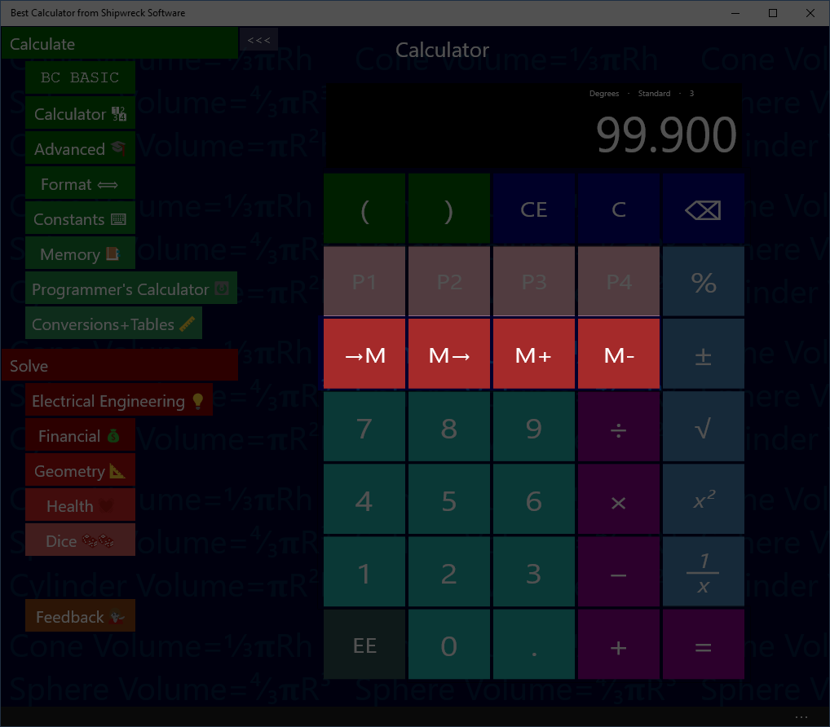

Basic Memory operations: get from memory, store into memory

## Memory operation

The four memory keys let you save and recall values from the calculator.

Save a number to memory

Key in: 45 🡪M  
Answer: 45 is displayed

Recall a number from memory

Key in: C M🡪  
Answer: the screen is cleared and then 45 is displayed

The C key will clear the display. M🡪 will copy the memory value to the display.

See the Memory Page section for advanced memory usage.

## Example

You are planning on doing a number of calculations using your local tax rate (in the example, 8.25%). You can store the tax rate into memory and then use it later on.

Calculate the tax (8.25%) on three different values (10, 20, and 30)

Key in: 8.25 →M 10 + M→ % =  
Answer: 10.825

Key in: 20 + M→ % =  
Answer: 21.65

Key in: 30 + M→ % =  
Answer: 32.475

The →M key places the current number into memory. The M→ key retrieves the memory value and places it into the display just as if you had typed it.

## Memory Add and Subtract

The M+ key adds the current number to the existing memory value.

Key in: 45 🡪M M+ M🡪  
Answer: 46

First the number 45 is put into memory (45 🡪M). Then the memory value is incremented (M+). Finally, the incremented value is displayed (M🡪)

The M+ key subtracts the current number to the existing memory value.

# More Math

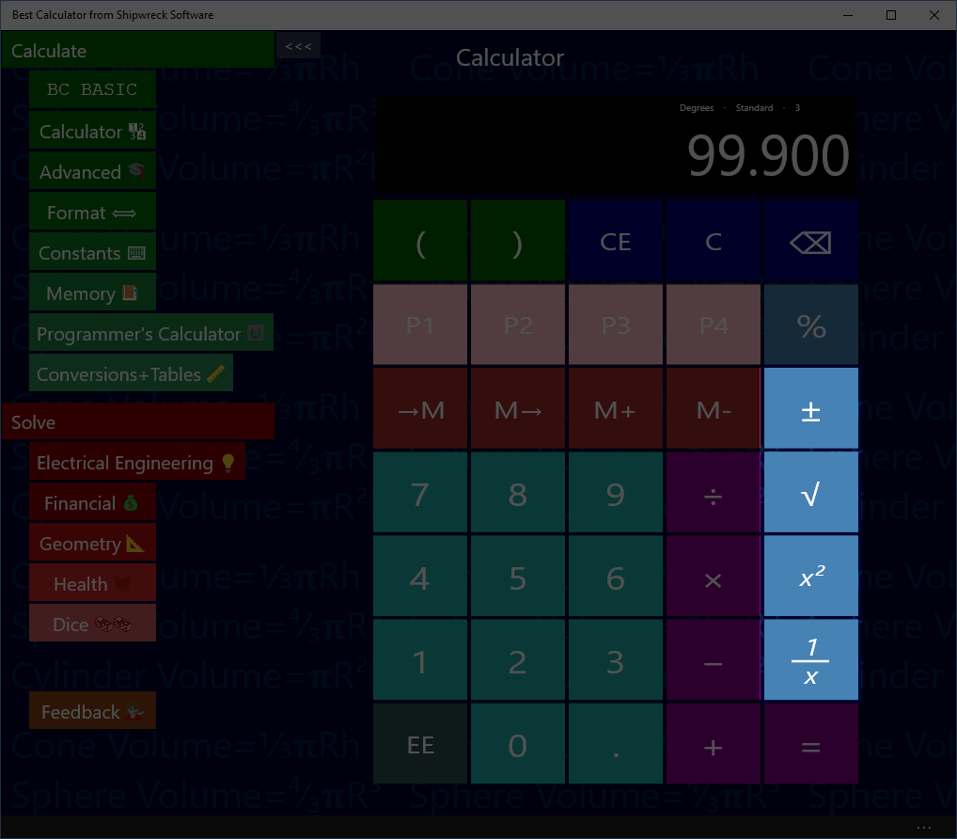

More math: square root, square, inverse, change sign

## Squares

If you have a square 5 inches on a side, how many square inches is the square?

Key in: 5 x²  
Answer: 25

The x² key is the same as multiplying the current number by itself. In the example, it’s the same as entering 5 × 5 =

The x² key is immediate: it will square the number instantly without you having to enter the = key.

## Square Root

The √ square root key finds the square root of the current number.

If you have a tile and know that it is 25 square inches, how long is it on a side?

Key in: 25 √  
Answer: 5

## Inverse (*1/x*)

What’s ⅓ + ⅓?

Key in: 3 *1/x* + 3 *1/x* =  
Answer: 0.666

## The ± key

The ± key will change the current number from positive to negative or from negative to positive.

# Scientific Notation

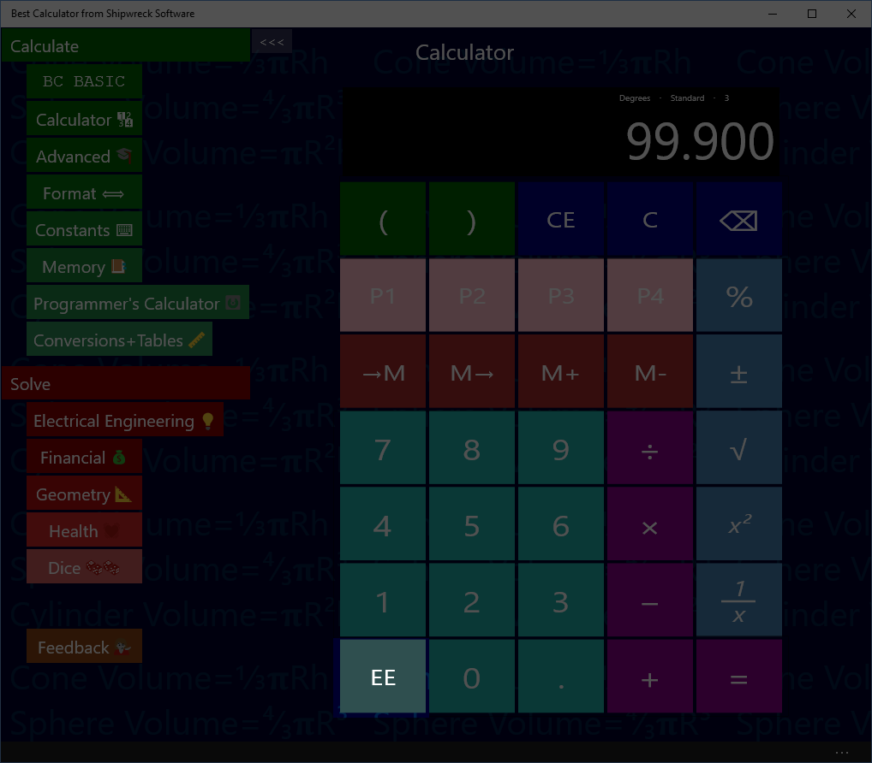

Scientific (Exponential) notation

## Using the EE key

Some numbers are too large or too small to enter conveniently. This is where you can use the EE key to enter your number in exponential (scientific) notation.

Avogadro’s number is about 6.022 × 1023 and the atomic weight of water is about 18. How many molecules of water are in a single gram of water?

Key in: 6.022 EE 23 ÷ 18 =  
Answer: 3.34 E 22, or 3.34 × 1022

To enter a negative exponent, use the – key. The ± will change the whole number from positive to negative.

The mass of a single oxygen atom is about 2.68 × 10-26 kilograms. What is the mass of 20 atoms of oxygen?

Key in: 2.68 EE – 26 × 20  
Answer: 5.36E-25 or 3.34 × 10-25

Best Calculator will display the result based on the selection in the Format section. If you are dealing with small numbers and are just seeing a “0” instead of a result in scientific notation, go to the Format screen and enter “Exponent”.

# Percent Key

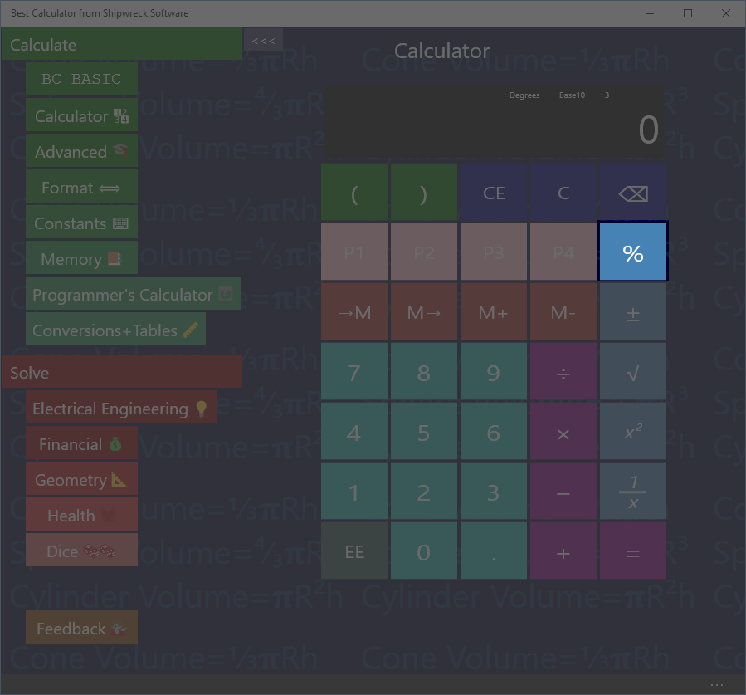

Percent Key

## Percent

Given that you’re already entered an equation (for example 72 – 20), pressing the % key will convert the 20 into 20% of 72.

If you have entered only a single number (e.g., just “5”), then the % key will convert the 5 into 0.05 (as if calculating 5% of 100)

## Calculating sales tax

You are buying an item that costs $72 and the sales tax is 5%. What is the total cost?

Key in: 72 + 5 % =  
Answer: 75.60

## Calculating sales with a percent discount

You are buying an item with a 20% pre-tax discount, and the sales tax is 5%. What’s the total?

Key in: 72 – 20 % + 5 % =  
Answer: 60.48

# Angle keys on the Advanced calculator

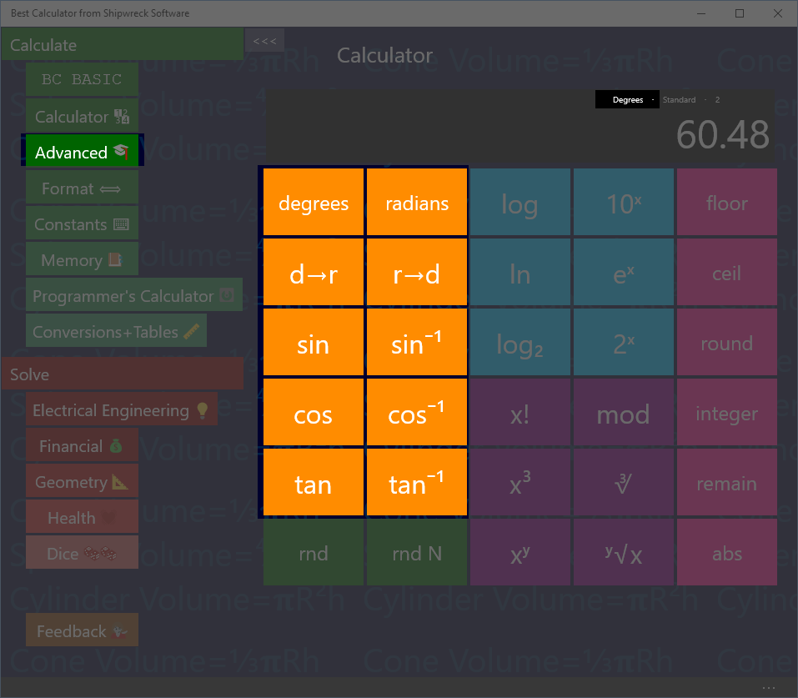

Angle keys: sin, cos, tan, inverses, and degrees, radians and conversions.

The angle keys are part of the Advanced calculator.

Best Calculator includes sin, cos and tangent and their inverses.

## Calculate in degrees or radians

Calculations can be done in either degrees or radians. The display will show (in small type) whether you are currently in degree mode or radian mode.

Press the degrees button to switch to degree mode; press the radians button to switch to radian mode.

Press the d🡪r button to convert a number in degrees to a number in radians. Press the r🡪d button for the reverse conversion from radians to degrees.

Convert 30° to radians

Key in: 30 d🡪r  
Answer: 0.5236

The d🡪r and r🡪d keys work regardless of the degrees and radians settings.

## Sin, Cos, Tan

Calculate the sin of 30°

Key in: 30 sin  
Answer: 0.50

If you get an answer of -0.9880, the calculator is in *radians* mode; key in degrees to switch to calculating in degrees

Calculate the cosine of ¼π

Key in: radians 0.25 × π = cos  
Answer: 0.7071

You can perform the same calculation using parenthesis

Key in: radians ( 0.25 × π) cos  
Answer: 0.7071

The result of sin, cosine and tangent are always between -1 and 1.

## Inverse Sin, Cos, Tan

(Also called arcsine, arccosine and arctangent)

Given the sin, cosine or tangent of an angle, you can get the original angle back out. The result will be an angle between 0° and 360° degrees or 0 to 2π radians

Calculate the inverse sin (arcsine) of 0.5

Key in: 0.5 sin-1  
Answer: 30

If you get the answer 0.5236, the calculator is in radians mode; key in degrees to switch to degree mode.

The input values must be between -1 and 1; otherwise a NaN value is calculated.

The notation sin-1 is the John Herschel notation; it means “inverse sine” and not “raised to a power”.

# Logarithms on the Advanced calculator

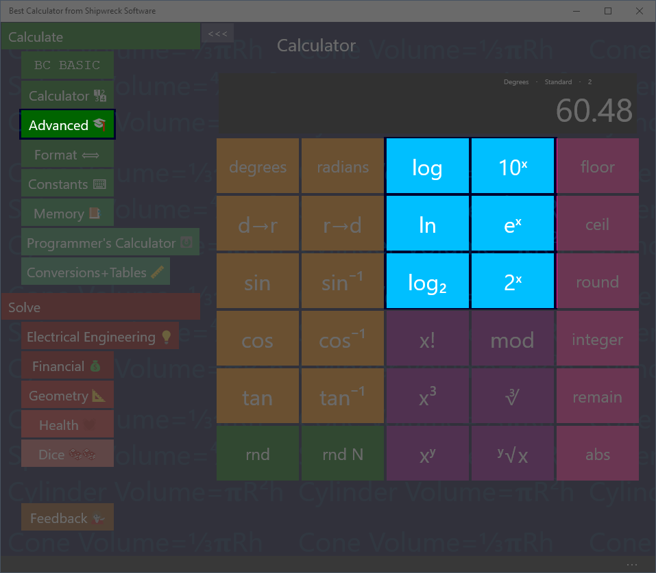

Logarithm keys

Logarithm keys are part of the advanced calculator.

Calculate the logarithm (base 10) of 100, 1000 and 100000,

Key in: 100 log  
Answer: 2

Key in: 1000 log  
Answer: 3

Key in: 100000 log  
Answer: 5

With base-10 logarithms, the log of a number Is related to how many digits long the number is.

Best Calculator lets you calculate logs in three bases:

* The log key calculates using base 10
* The ln key calculates using base *e* (also called the natural logarithm)
* The log2 key calculates using base 2 (binary, also called lb)

Each key is paired with the corresponding power key: 10x, ex, and 2x.

The base 2 logarithm is used by computer programmers to determine how many *bits* are required to hold a number of a certain magnitude.

How many bits are needed to hold a number that hold 26 distinct values?

Key in: 26 log2  
Answer: 4.7004

# Powers, roots, x!, mod on the Advanced calculator

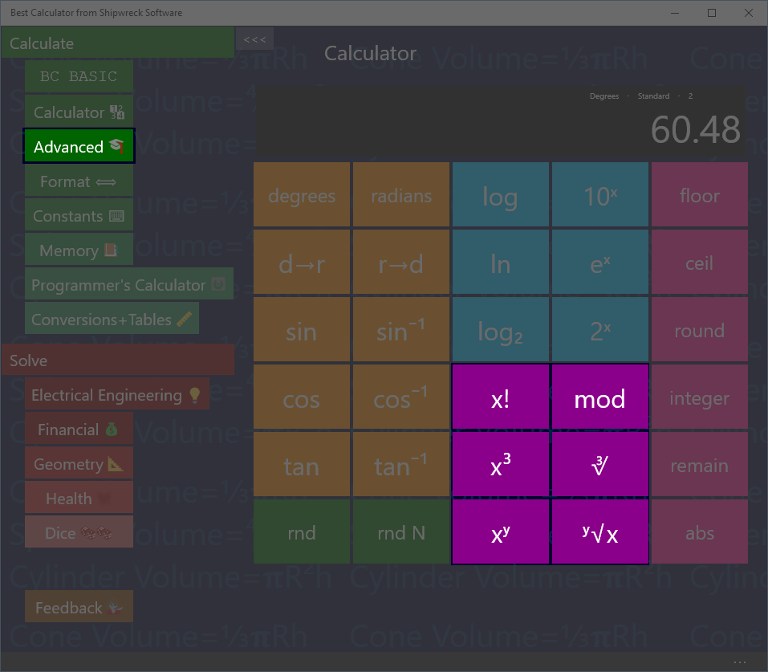

Powers and roots plus factorial and the mod operator.

## Factorial

Calculate 6!

Key in: 6 x!  
Answer: 720

6! is another way of writing 6 x 5 x 4 x 3 x 2 x 1

## Mod

The Mod (Modulo) key calculates the remainder of a number. The remainder is the part that's left over when one number is divided by another.

What is the reminder of 7 / 4?

Key in: 11 Mod 4 =  
Answer: 3

4 goes into 11 2 times with 3 left over.

## x3 and cube root

What is 4.53? (4.5 raised to the 3rd power)

Key in: 4.5 x3  
Answer: 91.125

What is cube root of 27?

Key in: 27 ∛   
Answer: 3

## Arbitrary power

Best Calculator calculates numbers raised to arbitrary powers and take arbitrary roots. The powers do not have to be integers.

What is 64

Key in: 6 xy 4 =

Answer: 1296

What is the 4th root of 32?

Key in 32 y√x 4

Answer: 2.3784

# Rounding and abs on the Advanced calculator

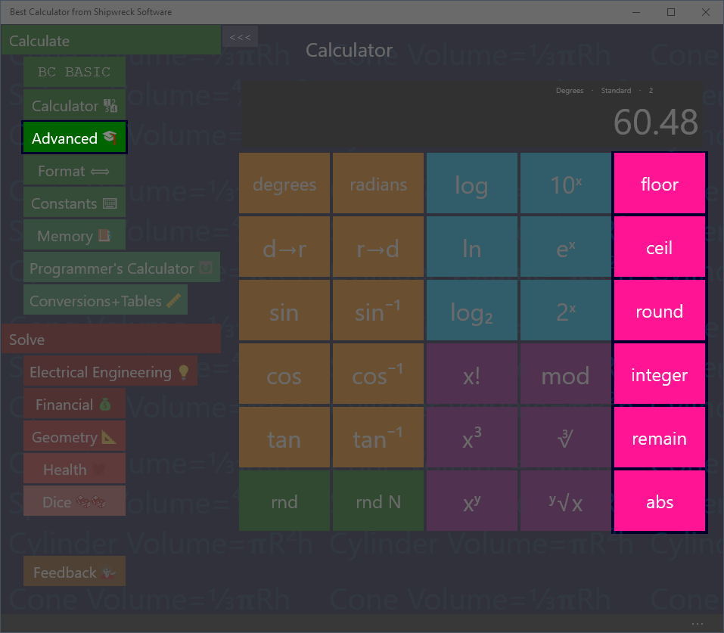

Rounding, remainder and absolute value

Rounding keys are in the advanced calculator.

**Floor**: round downwards to be a smaller number. The floor of a negative number (like -3.5) is rounded to a smaller number (-4)

**Ceil**: round upwards to a larger number. The ceil of a negative number (like -3.5) is rounded up to a larger number (-3)

**Round**: round towards to closest number. For example, 3.2 round is 3; 3.8 round is 4. Numbers that are exactly half-way between will round to the nearest even number (1.5 rounds to 2 and 4.5 rounds to 4)

**Integer**: rounds towards zero. The integer value of 4.5 is 4; the integer value of -5.5 is -5. This is just like removing everything past the decimal point.

The number line

The number line. Numbers further to the right are larger; numbers further to the left are smaller. Note that -10 is smaller than -2.

**Frac**: returns the fraction part of a number: the numbers past the decimal point

Calculate the remainder of 5.83

Key in: 5.83 remain  
Answer: 0.83

**Abs**: convert negative numbers into positive numbers.

What is the absolute value of -4.5?

Key in: 4.5 +- abs  
Answer: 4.5

Note that the +- key turns the positive (4.5) number into a negative number.

# Random Numbers on the Advanced calculator

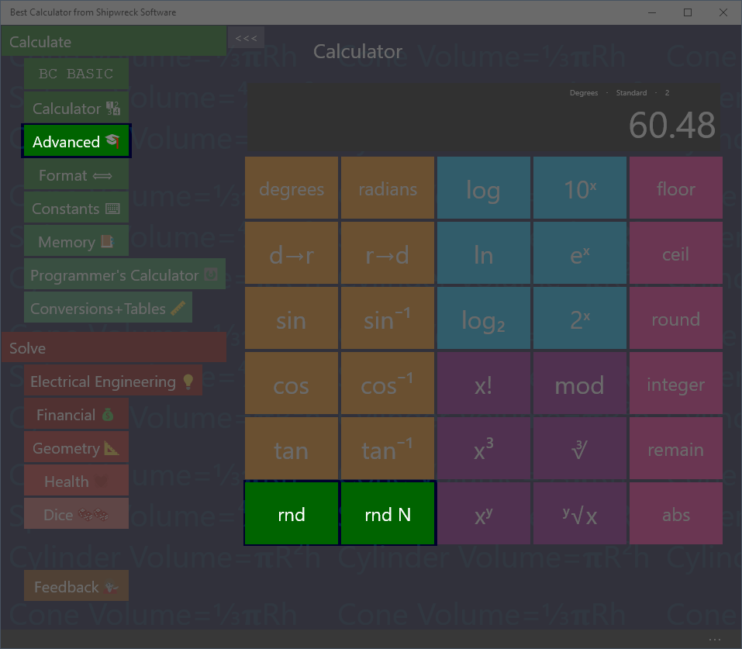

Random Numbers

Best Calculator has two different random number keys.

The rnd key will place a random number between 0 and 1 into the result.

Rnd N will place a random integer into the display; it will be between 1 and the number in the display.

Make a random number between 1 and 12

Key in: 12 rnd N  
Answer: 3 (might be any number 1 to 12)

Make a random number between 0 and 1

Key in: rnd  
Answer: 0.841 (might be any number 0 to 1)

# Formatting

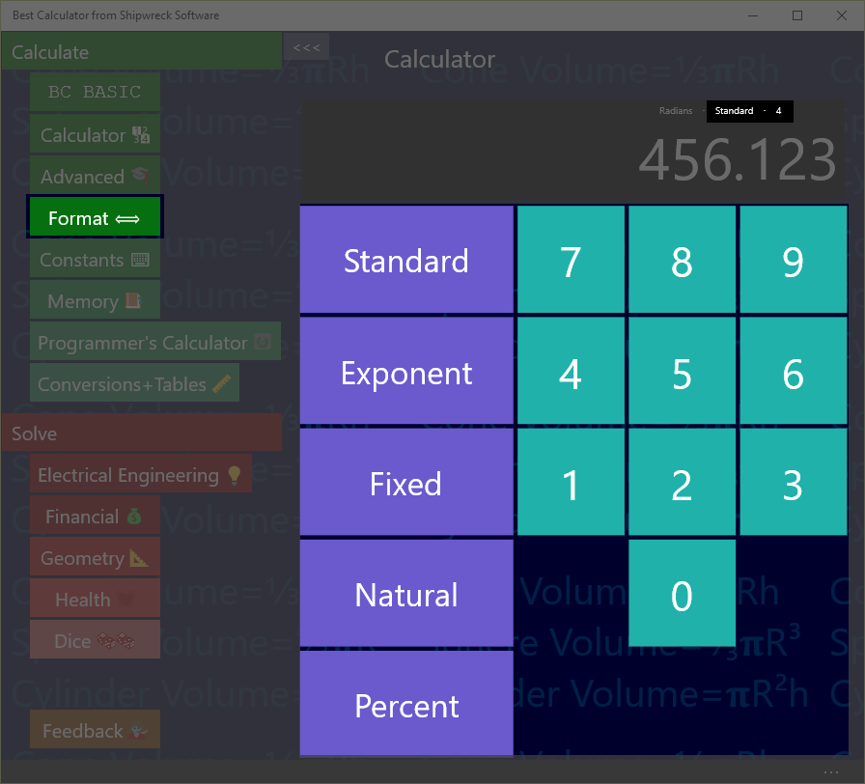

Change how your results are displayed with the Format page.

Set how your results are displayed with the Format page.

Best Calculator can display numbers as regular numbers (“456.123”) or as exponents (“4.56123E+002)

You can pick how many numbers after the decimal place to display.

The current formatting is always shown on the result display, right above the result. In the example, the display is “standard with 4 digits past the decimal point”

## Standard formatting

|  |  |
| --- | --- |
| Regular number or exponent? | Automatically selected |
| Special features | “zero suppress” removes extra zeros after the decimal point. |

The standard format is the one that’s on by default when you first start the calculator. It will automatically switch between regular number and exponential form. The number of digits past the decimal place is a *maximum* number of digits; extra zeros are automatically suppressed (as is the decimal point).



In the example, up to 4 digits will be printed after the decimal point. The actual number (456.123000) has only zero beyond the “.123”, and so they are suppressed.

## Exponent formatting

|  |  |
| --- | --- |
| Regular number or exponent? | Always exponent |

Sometimes called scientific notation, the exponent format is useful when you are dealing with large numbers much of the time.



In the example, the display (4.5612E+002) represents the number 4.5612 × 102. This in turn is 4.5612 × 100, or 456.12. The value is rounded from it’s real value (456.123) because the display has been set to only show 4 digits of precision.

A negative exponent (4.5612E-002) is less than zero (0.045612)

Exponent notation is equal to .NET’s “E” format

## Fixed formatting

|  |  |
| --- | --- |
| Regular number or exponent? | Regular number |
| Special features | Can overflow the display |

The fixed format always displays using regular notation with a certain number of figures after the decimal point. It’s often used when dealing with repeated calculations where each calculation should display the same way



In the example, exactly 4 digits will be printed after the decimal point.

If the number is too large to fit into the display, the display will be resized. After a certain point, the number will no longer fit, and will be truncated.

Fixed formatting is equal to .NET’s “F” format

## Natural formatting

|  |  |
| --- | --- |
| Regular number or exponent? | Regular number |
| Special features | Displays with commas |

Similar to Fixed formatting, Natural formatting will display the number with comas separating the units.



If the number is too large to fit into the display, the display will be resized. After a certain point, the number will no longer fit, and will be truncated.

Fixed formatting is equal to .NET’s “N” format

## Percent formatting

|  |  |
| --- | --- |
| Regular number or exponent? | Regular number |
| Special features | Number is display as a percent: it’s multiplied by 100 and displayed with a percent sign |

The percent format is used when you need to show a number as a percent.



In the example, the number has been automatically multiplied by 100 and a percent sign is displayed. Note that the “real” number inside the calculator isn’t changed: adding 1 to the example (456.123) results in 45**7**.123 which is displayed as 457,12.3000%

Percent formatting is equal to .NET’s “P” format

# Constants

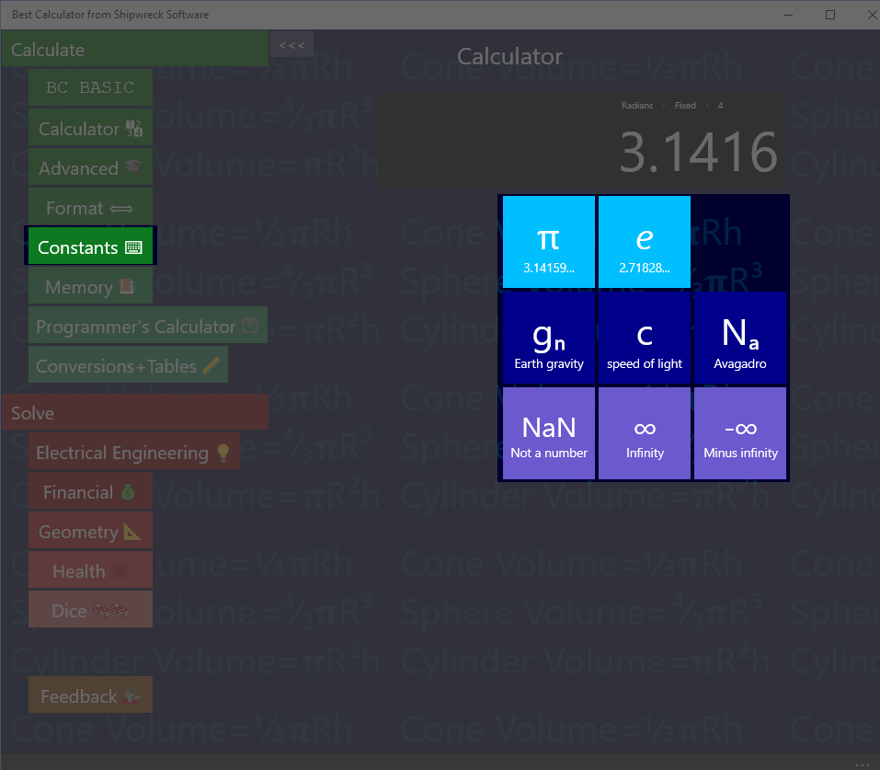

Useful constants

## π and e

Press the π button to set the display to the value of π (about 3.1416).

Press the e button to set the display to the value of e (about 2.7183)

Calculate 4 * π

Key in: 4 × π =  
Answer: 12.5664

## gn c and Na

gn (about 9.8) is the standard gravity in metric units; it’s the gravitational acceleration on Earth, measured in meters/second2.

c is the speed of light (about 299792458) in meters/seconds

Na is Avogadro’s number (about 6.022x1023) is the number of atoms or molecules in one *mole* of a substance. For example, there are Na atoms of carbon (specifically, 12C) in 12 grams of carbon.

## NaN, ∞ and -∞

Best Calculator includes three special constants that can’t be typed in otherwise.

NaN (Not a Number) means that a numeric value is not meaningful. For example, an inverse sin (sin-1) is only meaningful for input values -1 to 1. Calculating sin-1 of 2 will result in a NaN result.

∞ is positive infinity, and -∞ is negative infinity.

# Memory Page

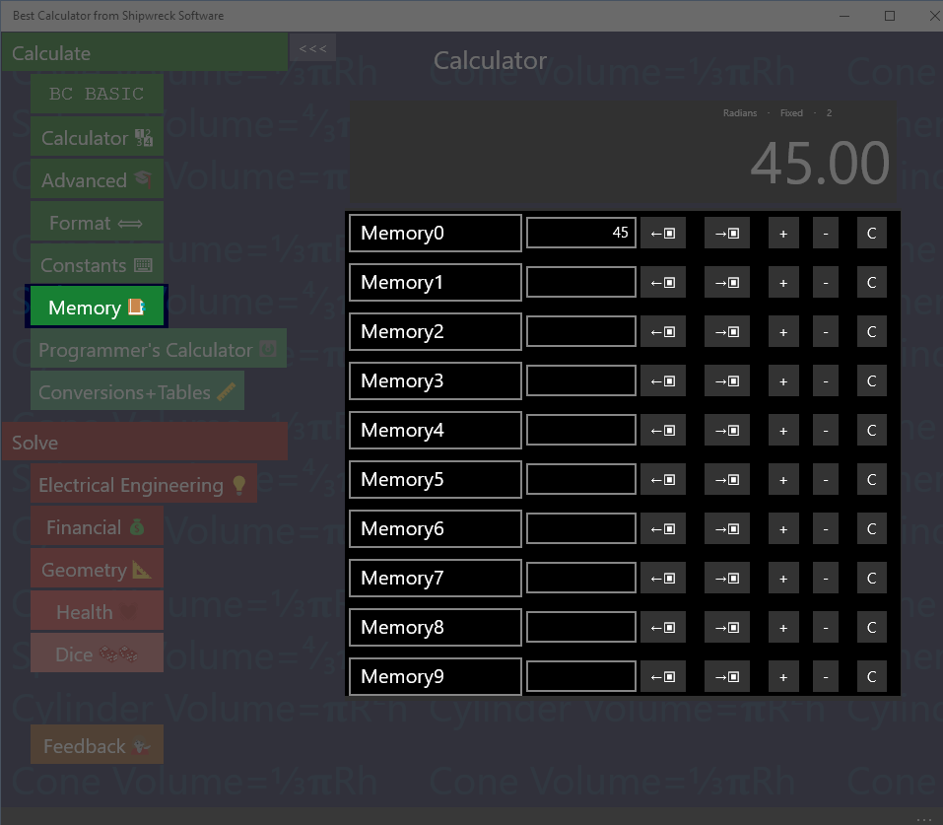

Memory operations: rename, set, get from display, copy to display, increment, decrement, clear.

The Memory page gives you access to 10 named memory slots. Each slot can be set, changed, and named.

The first memory slot (normally called Memory0) is the memory used by the main Calculator screen for memory operations.

## Show the operation of Memory0

The main calculator screen includes 4 memory keys (🡪M, M🡪, M+ and M-). These directly manipulate the first memory slot.

Enter 45 into memory slot 0. Go to the Calculator page.

Key in: 45 🡪  
Answer: 45 is displayed

Now go to the Memory page. The first memory slot is set to 45.

## Saving and Roaming

The memory values are roamed: when you set a memory value, the value and name are roamed to all of your computers (where you’re logged in with the same Microsoft Account). The values will be saved between calculator runs; you can exit the calculator and the values will be preserved for the next time you run Best Calculator.

## Name a memory cell

Click on the name of a memory cell to rename it.

Set, Increment, Decrement

Click on a memory value to change it. You should only enter numeric values!

Click on the + key to increment a memory value

Click on the – key to decrement a memory value

## Get from display and Copy to display

The ←▣ button gets data from the display into the memory slot.

The →▣ button copies data from the memory slot to the display

## Clear

The C button clears the memory slot

## Memory and BC Basic

The BC Basic Memory extension can get and set values from the calculator memory slots.

# Hex, Decimal, Octal, Binary on the Programmer’s calculator

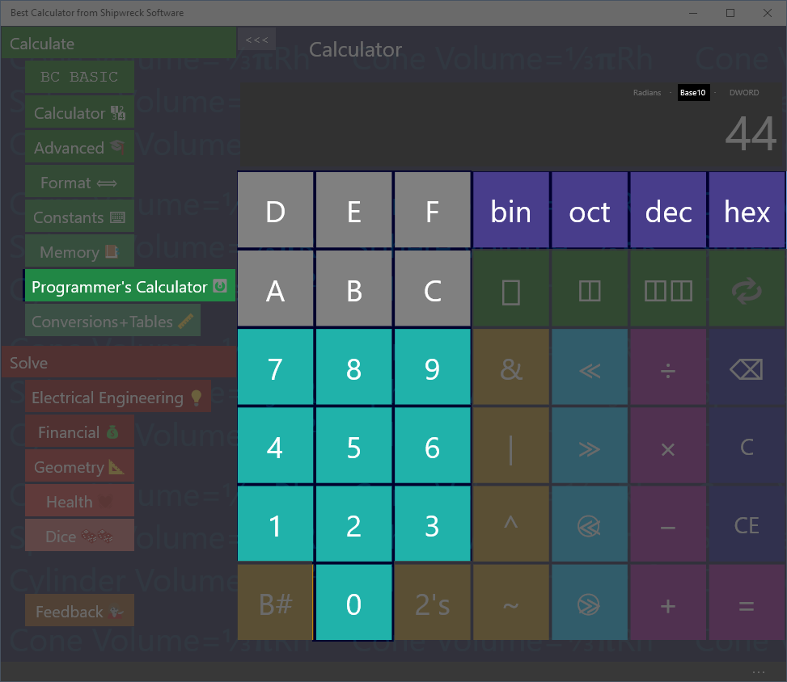

Hex, Decimal, Octal and Binary entry and conversions are built in

The Hex, Decimal, Octal and Binary entry and conversions are part of the Programmers Calculator.

## Setting the mode

Press the bin, oct, dec or hex buttons to switch to binary (base-2), octal (base-8), decimal (base-10) or hexadecimal (base 16).

The display will show which mode the Programmer’s Calculator is in.

To enter a value, simply press the keys 0 to 9 or A-F. Valid keys will be displayed in Cyan; invalid keys are gray. In the example, the calculator is in decimal mode so that keys 0 to 9 are all valid. In binary mode, only keys 0 and 1 are valid; in octal mode only keys 0 to 7, and in hexadecimal mode keys 0 to 9 and A to F.

Add the number 1A to the number 12

Key in: hex 1 A + 1 2 =  
Answer: 2C

## Converting between bases

To convert from the current base to a different base, simply press the new base number. The existing display will be converted to the new base

Convert 2C16 into decimal

Key in: hex 2 C dec  
Answer: 44

# Bit Operators on the Programmer’s calculator

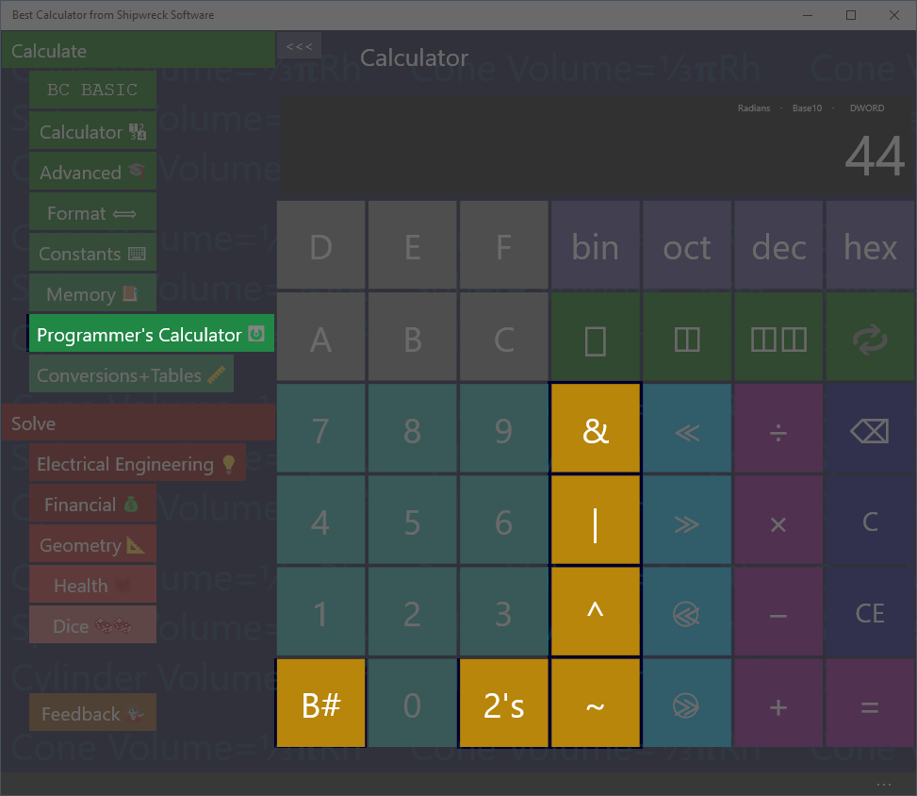

Basic Memory operations: get from memory, store into memory

The Bit operators are part of the Programmer’s calculator

## B# (count bits)

Use the B# key to count the number of ‘1’ bits in the current number

How many bits are ‘1’ bits in the hex number 44?

Key in: hex 4 4 B#  
Answer: 2  
  
Hex 44 is binary 01000100. Only two of the bits of that number are ‘1’ bits.

## Inverse (~) and 2’s complement

The ~ key will invert each of the bits of the current value. This is also called the “1’s complement” of the number.

The 2’s button calculates the “2’s complement” of a number. This is what (almost every) computer stores as the negative value of a number.

How does a computer store -1?

Key in: dec 1 2’s  
Answer: FFFFFFFF

## And (&), Or (|) , Xor (^)

The And, Or and Xor keys will and, or xor (exclusive-or) two numbers together.

What is 3 AND 4?

Key in: 3 & 4 =  
Answer: 7

# Bytes and Swabbing on the Programmer’s calculator

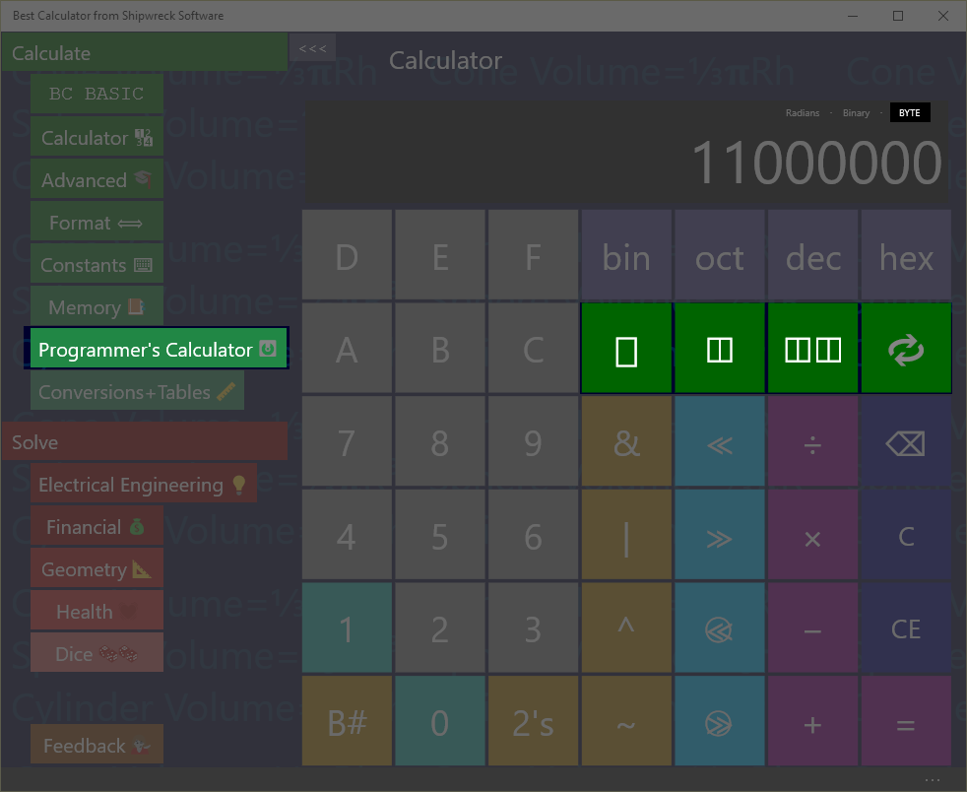

Basic Memory operations: get from memory, store into memory

The bytes and swap operators are part of the Programmer’s calculator.

## Bytes

Many programmer calculations change depending on the number of *bytes* that are involved in an operation. Common sizes are byte (**▯**), word (2 bytes, **◫**) and dword (4 bytes, **◫◫**).

The result display shows the number of bytes as “BYTE”, “WORD” and “DWORD”. Results that are larger than the current setting will be truncated.

## SWAB (Swap Bytes) key

The key performs the SWAB (swap bytes) operation. This is commonly used when dealing with network operations: most network protocols send data using “big endian” format while most PCs are in “little endian” format.

What’s the network byte order for port 80? Port numbers are sent as 2 bytes.

Key in: ◫ dec 8 0   
Result: 20480

Explanation:

* ◫ switches to WORD (2 byte) mode
* dec switches to decimal mode
* 8 0 puts the number 80 into the display
*  (SWAB) switches the first and second byte around

# Shift operators on the Programmer’s calculator

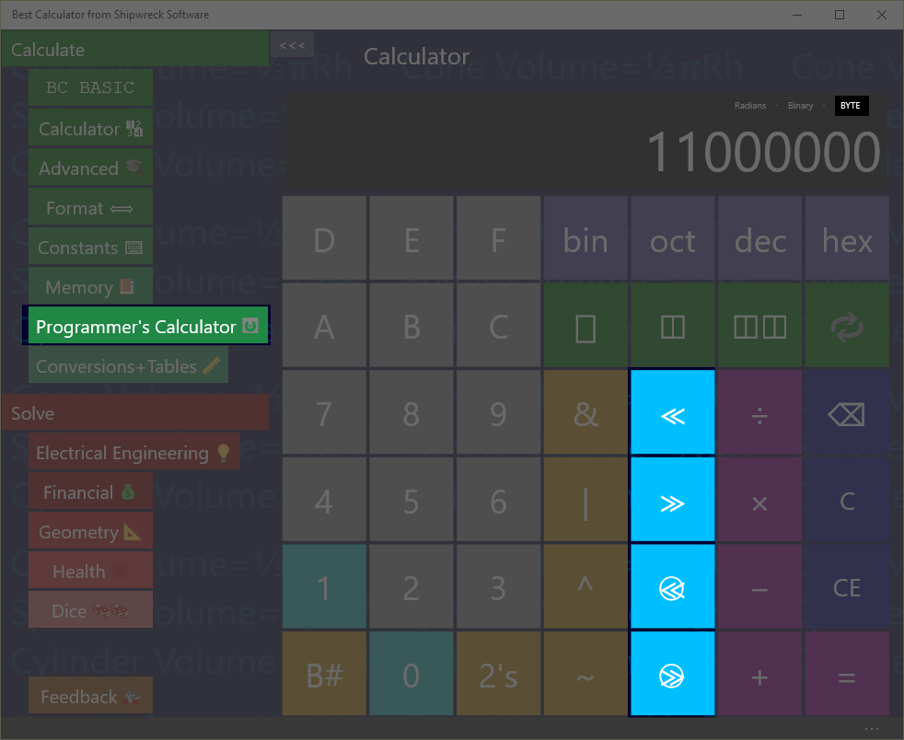

Shift operators: left and right, left and right rotate (ring shifts), and the byte/word/dword display

The Shift operators are part of the Programmer’s calculator

The shift operators (and especially the rotate keys) use the byte setting.

Shift hex F0 left by 2 bits

Key in: hex F 0 ≪ 2 =  
Answer: 3C0

In binary, F0 is 1111 0000. Shifted left 2 bits, the result is 11 1100 0000, which is 3C0. Bits introduced on the right are zero.

Ring-shift left F0 by 1 bit as a single byte

Key in: ▯ hex F 0  1 =  
Answer: E1

In binary, F0 is 1111 0000. With a normal shift, the bits that “shift out” will be dropped and new bits are zero. With rotate (ring shift), the bits would have been dropped are reintroduced on the other side.

In binary, F0 is 1111 0000. When rotated, the top bit (1) is put in as the lowest bit, resulting in 1110 0001, or E1.

# Programmer’s Math

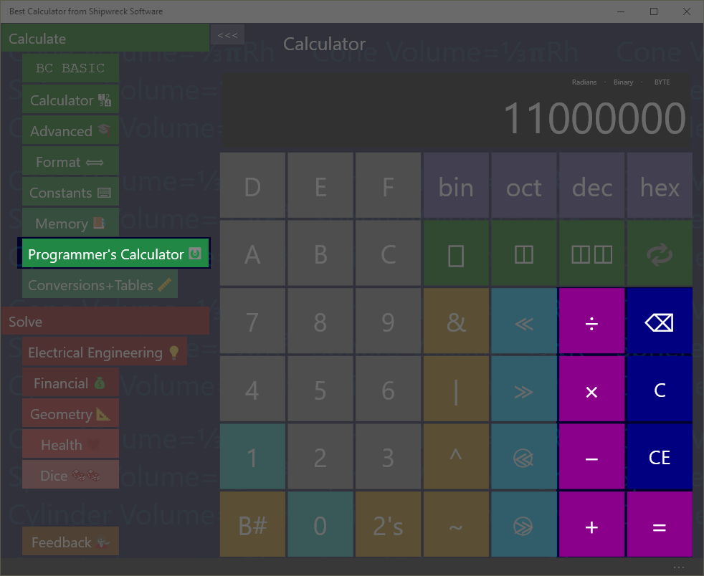

The programmer’s calculator performs standard math operations

The programmer’s calculator can act as a regular calculator, but only for integers.

Divide 7 by 3

Key in: 7 ÷ 3 =  
Answer: 2

Unlike the regular calculator, where 7 ÷ 3 is 2.3333, the Programmer’s Calculator is strictly an integer-only calculator.

Additionally, the byte settings will force some results to be truncated

Multiply 99 × 99 in byte mode

Key in: ▯ 9 9 × 9 9 =  
Answer: 73

In the regular calculator, 99 × 99 would be 9801. This is (256x38 + 73). Only the bottom byte (the 73) is kept from the calculation. The rest is discarded.

# Statistical calculator

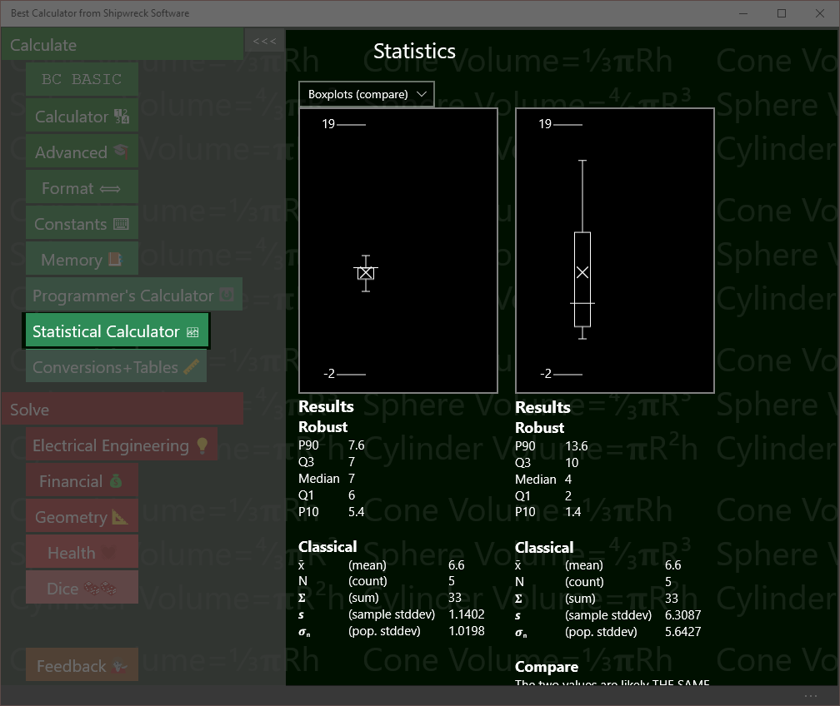

Statistical calculator showing the difference between two samples

The Statistical calculator takes in one or two lists of numbers and computes

* Robust statistics like median and interquartile range
* Classical statistics like mean and standard deviation
* T-Tests to compare two groups of numbers
* Linear regression between two paired groups of numbers

The statistical calculator will display the data either as one or two boxplots (specifically, *Tukey* boxplots) or as an XY scatterplot.

In all cases, Best Calculator always computes all possible values. You simply type your numbers into the data boxes, and Best Calculator will compute and display the results.

## Parts of the Statistical calculator screen

The Statistical calculator screen is divided into three parts: the graphs, the computed results, and the data. There are two data entry boxes, a left box and a right box, resulting in a left hand data set and a right-hand data set.

1. **Graphs at the top** present a pictorial view of your data. You can chose the kind of graphs: two independent boxplots, two boxplots for comparison (their Y axes will be set to be the same), an XY Scatter plot, or no graph
2. **Computed results** for the left and right data sets. The left-hand data set will always compute Robust and Classical statistics. The right-hand data set in addition will compute a T-Test comparison between the left and right data sets and a linear regression between the left and right data sets.
3. **Left and right data sets** and their data entry boxes. The data is simply a list of numbers; you can copy and paste from Excel or simply type the data in.

## Entering Data

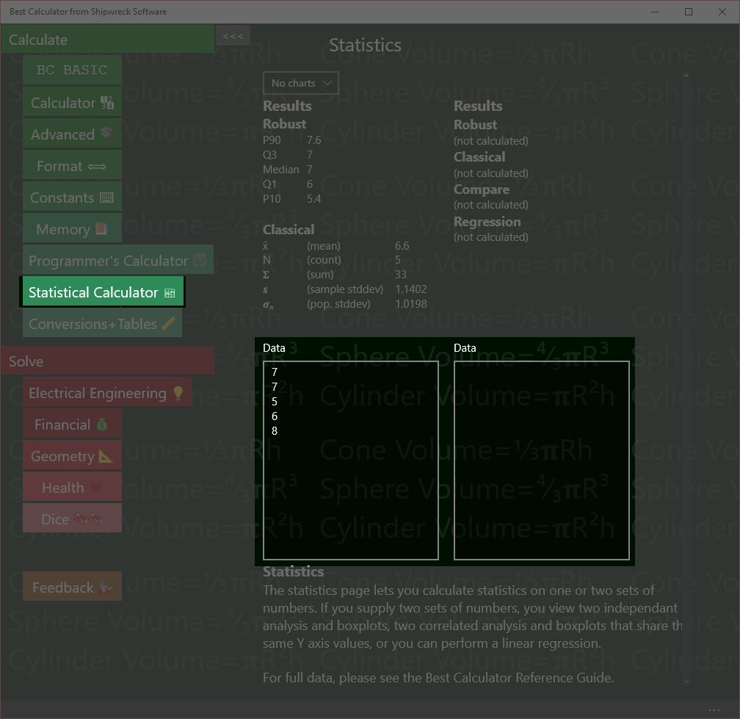

Enter data either into the left or right text boxes. Statistics are automatically computed as you type.

The left box still has the default data in it; the right box has been cleared. The graphs have been turned off.

Enter data into the left and right data boxes.

When Best Calculator starts, each box is marked “Data” and contains some default values so you can see what kind of statistics and graphs Best Calculator will produce.

To enter data, simply click on either box. Data should be entered with one item per line. To enter a lot of data, you can paste the data into the text box.

Best Calculator is a calculator, not a spreadsheet, and does not understand file formats like CSV (comma separate value) files, and does not have a way to read a file from disk.

You can paste values directly from Excel. In Excel, highlight and copy the column of numbers you want to compute statistics for. Then click on the text box in Best Calculator and paste.

Lines that are not understood as numbers will be ignored. The first line with text in it will be the title of the data. For example, if you copy a column of numbers from Excel, you can include the column header and it will be used as the data title.

As you enter data, Best Calculator will automatically recalculate your statistics. The left help data box computes classical and robust statistics. The right hand column will also compute a T-Test to compare the two sets of data and (if the two sets have the same number of entries), will compute a linear regression.

## Classical Statistics (Results)

**Classical**

x̄ (mean) 6.6  
N (count) 5  
𝚺 (sum) 33  
𝙨 (sample stddev) 1.1402  
𝝈**n** (pop. stddev) 1.0198  
RSD (rel. stddev) 0.1728

Computed classical statistics

Both the left and right hand data sets will compute classical statistics. Classical statistics work best with symmetrical, bell-shaped **normally** distributed data.

Lines that are text, not numbers, or which are blank are never included in the values.

**Mean**The mean (**x̄**) of the numbers is the arithmetic mean, or average of the numbers. It’s calculated by adding up all the numbers and dividing by the count of the numbers.

**Count**The count (**N**) of the numbers is simply the number of numbers in the data box.

**Sum**  
The sum (𝚺) of the number is the total of all of the numbers added together.

**Sample Standard Deviation**  
The sample standard deviation (sample stddev, or 𝙨) is the standard deviation for a sample. It’s very similar to the population standard deviation, but the N value used is (N-1). The standard deviation informs you of the overall spread of the data. Data sets where the numbers are close together will have smaller standard deviations.

**Population Standard Deviation**The population standard deviation (pop. stdev , or 𝝈**n**) is the standard deviation assuming that the data in the data box is the entire population and not a sample. It’s similar to but always a little smaller than the sample standard deviation.

**Relative Standard Deviation**  
The Relative standard deviation (**RSD**) is a normalized version of the sample standard deviation. It’s the computed by dividing the sample standard deviation by the mean. It’s useful for determining the “spread” of a sample without having to mentally compare the standard deviation with the mean.

## Robust Statistics (Results)

**Robust**

P90 7.6  
Q3 7  
Median 7  
Q1 6  
P10 5.4

Computed robust statistics

Both the left and right hand data sets will compute robust statistics. Robust statistics are less sensitive to outliers than classical statistics. The values computed by Best Calculator are used to display the Boxplot.

Lines that are text, not numbers, or which are blank are not included in the value.

The **median** value is often used as a representative measure of the data. When the data is symmetrical, the mean (classical) and median (robust) are the same; when data is skewed, the median represents a more typical member of the data while the mean is more weighted towards the high end.

To calculate the robust statistics, the data is sorted. Each robust data point is the value that is a certain percentile of the overall data. For example, the median is the 50% percentile; half of the data points are larger than the median value, and half smaller.

|  |  |  |
| --- | --- | --- |
| Point | Percentile | Comments |
| P90 | 90th | The P90 measure is used to help estimate the spread of the data. In the boxplot, the P90 point is marked with a small circle. |
| Q3 | 75th | The Q3 (third quartile) is the ¾ mark. The box in the boxplot is bounded by the Q# and Q1 points. |
| Median | 50th | The median (Q2) is taken from the exact middle of the sorted data set. It’s marked by a long horizontal bar in the box of the boxplot. |
| Q1 | 25th | The Q1 (first quartile) is the ¼ mark |
| P10 | 10th | The P10 measure is the opposite of the P90 measure. In the boxplot, the P10 is also marked with a small circle. |

## Regression (Results)

**Regression**

Slope 0.0037  
Intercept 0.0094  
Correlation 0.9814  
StdErr Line 0.0007  
StdErr Slope 0.0004

Computed linear regression statistics  
Sample data:

|  |  |
| --- | --- |
| **Minutes** | **Thickness** |
| 1 | 0.0132 |
| 1.5 | 0.0151 |
| 2 | 0.0167 |
| 2.5 | 0.0177 |
| 3 | 0.0211 |

Use the regression data and the linear regression chart to tell if two data sets are related.

The data shows the thickness (in mils) of a layer of silver deposited onto a computer chip after a certain amount of time in a furnace.

The number of minutes is entered into the left hand data box; the thickness is entered into the right-hand data box. If both data sets have the same number of data points, Best Calculator will compute the linear regression statistics.

Values calculated are

**Slope** and **Intercept** is the best fit for a single straight line through the data. These values can be placed directly into the standard formula for a line, y = mx + b. The slope value is the m value, and the intercept value is the b value.

The **correlation** coefficient says how close of a match the data is. If the data isn’t correlated at all, the correlation is 0. A negative correlation means that as one value increases, the other decreases (also called a negative correlation). A value of 1 or -1 means that the data is perfectly correlated.

The **StdErr Line** (standard error of the line) and **StdErr Slope** (standard error of the slope) are tests of how noisy the data is and how good of a fit the computed slope and intercepts are.

## Compare with T-Tests (Results)

**Compare**

The two values are probably DIFFERENT.  
The p-value 0.0145 is <= target 0.05  
test Welch's t-test  
p 0.0145  
df 13.9359  
t 2.7894

Computed robust statistics

When two data sets are entered, Best Calculator will compute a Welch’s t-test value.

Welch’s t-test are used to decide if the two data sets are “the same” or “different”. The boxplots are used informally for the same purpose.

Note that the t-test is not perfect way to tell if two samples are “different”. For example, the numbers [10, 20, 30, 40] will be reported to be “possibly the same” as [25, 25] even through a person would declare them to be very different.

In the example, the two data sets are from two types of chemical analysis (<http://www.fao.org/docrep/w7295e/w7295e08.htm>)

The computed p-value helps answer the question, “are these two data sets likely to be from the “same” kind of data. If the p value computed is small (set to 0.05 in Best Calculator), the two data sets must not be the same and are therefore different. If the p value is large, then no conclusion can be drawn: perhaps the data is different, but perhaps it’s not.

Welch’s t-test is a more modern version of the Student’s t-test. It’s been shown to be as good as the Student’s t-test when the sample variances are the same, and better then they aren’t.

Although the primary calculation from the Welch’s t-test is the p value, the df (degrees of freedom) and t statistic are also presented.

## Boxplots (Graph)

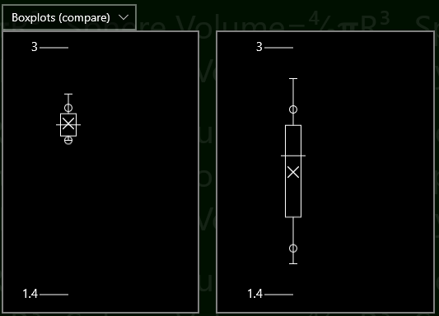Boxplots let you visually compare two data sets

Boxplots are a simple way to visually compare two data sets.

The tick marks on the left (1.4 and 3 in the example) tell you about what the range of data is. The tick values are automatically chosen to be the shortest numbers possible close to the data

The central box shows the inter-quartile range (IQR) for the data. Exactly ½ of the data falls within the central box; ¼ is less than and ¼ is more than the box.

The horizontal line in the center of the box shows the median of the data set.

The X in the boxplot (usually, but not always, somewhere in the box) is the average value. The X is the only part of the boxplot computed with classical statistics instead of robust statistics.

The whiskers can each be as long as 1.5× the IQR. They are trimmed back to show the furthest-away data point that fits in the whisker. Outliers are not drawn.

Unlike other box plot display, Best Calculator also shows the 10% and 90% percentile data points. These are useful when determining whether a process has a significant number of outliers or not. These are shown as the small circles, and will only be displayed when the data has at least 10 data points.

When you’re displaying two data sets, you can **compare** the two boxplot or display them as **independent**. In compare mode, the two boxplots are display using the same scale. In independent mode, the two boxplots are display with their own scale.

## XY Scatterplots(Graph)

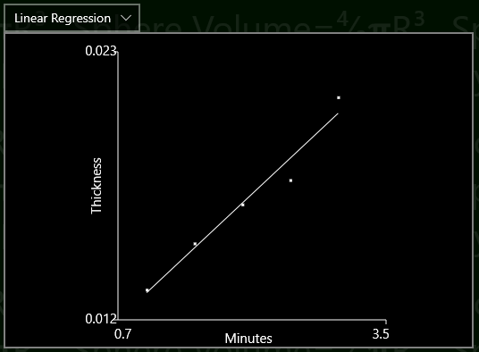XY Scatter plot with regression line lets you visualize the linear regression computation

Sample data:

|  |  |
| --- | --- |
| **Minutes** | **Thickness** |
| 1 | 0.0132 |
| 1.5 | 0.0151 |
| 2 | 0.0167 |
| 2.5 | 0.0177 |
| 3 | 0.0211 |

XY Scatterplots are a quick way to compare *paired* data.

The sample data used in the example is the same data used in the Regression example.

To make a scatterplot from your data, enter the *independent* data into the left hand data box and the *dependent* data into the right hand data box. Then chose “Linear Regression” as your graph type.

Each pair of data is plotted as a small dot, and the results of the regression analysis are drawn as a straight line. The headers will be displayed as the X and Y axis labels.

The min and max axis values are picked based on the data and are not settable.

Highly correlated data will be plotted close to the regression line; uncorrelated data will be plotted randomly, neither close to nor avoiding the regression line. The *correlation coefficient* is computed and displayed as part of the correlation results.

# Conversions

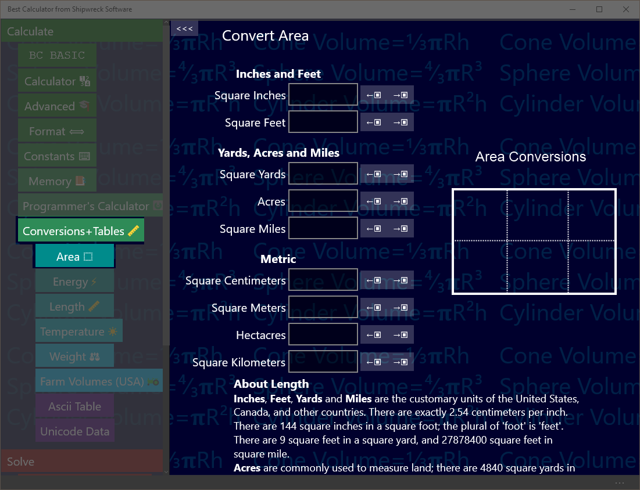Conversions include area, energy, length and more.

Conversions (like inches to centimeters) are in the Conversions and Tables section.

Tap that section first, and then tap the conversion page you want.

## Converting

All of the converters work the same way.

To convert a value, enter in the value you have (like “Square inches”) and read off from the resulting values.

Example: An apartment is 330 square feet. How many square yards is that?

Key in: tap ‘Conversions and Tables’ and then tap ‘Area’. Tap the text box next to ‘Square Feet’ and type in 330.   
Answer: read off 36.67 from the Square yards box

As you enter a number, the surrounding values are automatically calculated.

How many acres are in a square mile?

Key in: tap ‘Conversions and Tables’ and then tap ‘Area’. Tap the text box next to ‘Square Miles’ and type in 1.   
Answer: read off 640 from the Acres box

## Copy to and from the Calculator results display

You can copy a number from the calculator results display into any of the text boxes with the ←▣ button that’s next to each text box.

Your apartment is 10 yards by 4 yards. How many square feet is it?

Key in: in the main calculator, enter 10 × 3 =   
Tap ‘Conversions and Tables’ and then tap ‘Area’. Tap the ←▣ button next to the text box marked ‘Square Yards’. It will be set to 360.  
Answer: read off 360 from the Square Feet box

A square foot of carpet costs $2.04. What is the cost to carpet your apartment?

Key in: from the last example, tap the →▣ button next to the square feet box. Go to the main calculator; note that it has been set to 360. Key in × 2.04 =  
Answer: $734.40

## Area conversions

Best Calculator can convert between

* Square inches
* Square feet
* Square yards
* Acres
* Square miles
* Square centimeters, meters, hectares, and square kilometers.

A hectare is 10,000 square meters, or 1/100 of a square kilometer.

## Energy Conversions

Best Calculator can convert between:

* Ergs
* Joules
* Kilowatt-Hours
* Calories
* Food calories (KCAL)
* Donuts
* BTUs
* Therms

## Length Conversions

Best Calculator can convert between

* Inches
* Feet
* Feet + Inches (output only)
* Yards
* Miles
* Centimeters
* Meters
* Kilometers

## Temperature Conversions

Best Calculator can convert between

* Degrees Celsius (also called Centigrade)
* Fahrenheit
* Kelvin (absolute temperature in the metric system)
* Rankine (absolute temperature in Fahrenheit)

## Weight

Best Calculator can convert between

* Ounces
* Pounds
* Pounds + Ounces (output only)
* Short tons (2000 pounds)
* Long tons (2240 pounds)
* Grams
* Kilograms
* Tonnes (1000 kilograms; 2204 pounds)
* MMT (millions of metric tons)
* Grains
* Troy Ounces
* Troy Pounds
* Tolä (about 0.41 ounces)
* Sèr (80 Tolä)
* Maund (40 Sèr)

## Farm Volumes (US)

Best Calculator can convert between

* Cups
* Pints (2 Cups)
* Quarts (2 Pints)
* Gallons (4 Quarts)
* Pecks (1 Gallons)
* Bushels (4 Pecks)
* Liters

Given a weight in pounds per bushel, Best Calculator will also calculate the weight of an amount in bushels.

# Ascii Table

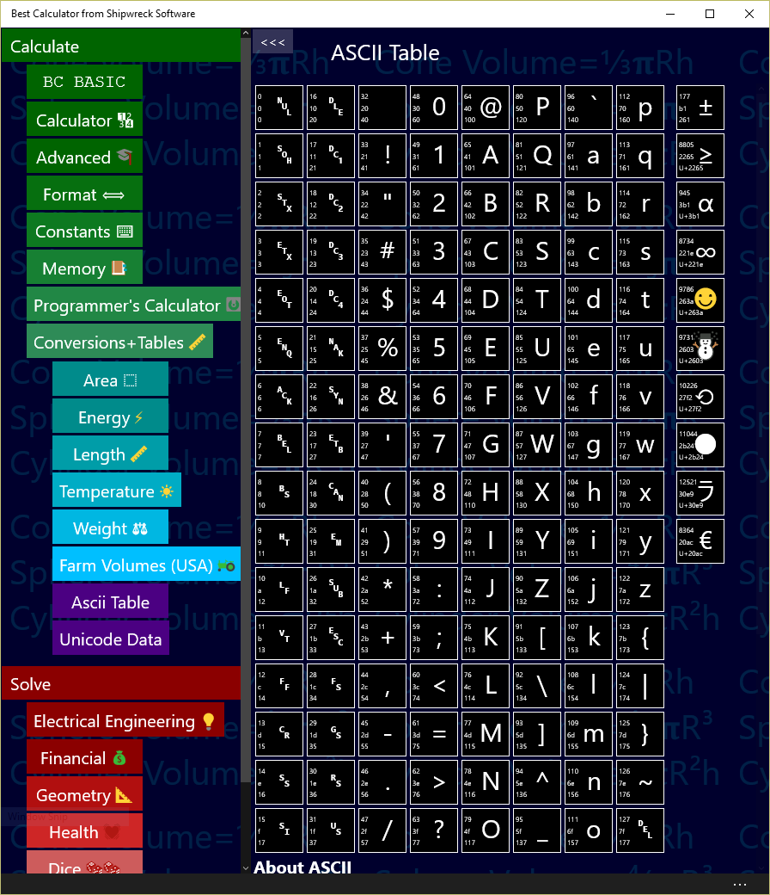

Basic Memory operations: get from memory, store into memory

The ASCII (American Standard for Computer Information Interchange) is a common way for computers to encode English-language text as numbers suitable for computer operation.

Programmers often need to convert from characters (like “@”) into their ASCII equal (the number 64).

The example shows the conversions for the “@” characters, sometimes called the “Ray” in honor of Ray Tomlinson, the creator of Internet email in the 1971.

|  |  |
| --- | --- |
|  | 64 is the decimal value of @  40 is the hex value of @  100 is the octal value of @ |

In the example, the “@” is shown along with the decimal (64), hex (40) and octal (100) values.

Example: replace a character with its percent encoding (used in encoding URLs from arbitrary characters). The rules for percent encoding is to replace the single character with three characters: a “%” sign and then two digits with the characters hex value. The @ hex value is 40, so to replace a single “@” in a URL, you need to replace it with “%40”.

# Unicode

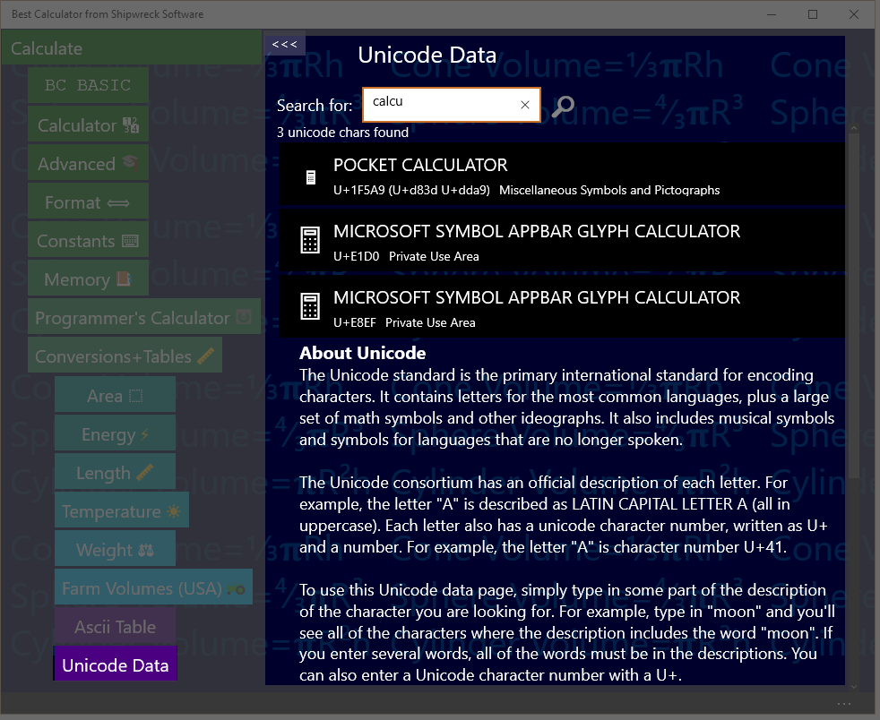

Find and copy Unicode characters including emoji

Unicode is the worldwide specification for characters from all languages, modern and ancient, including useful symbols for math and communications.

Phone emoji characters (like “face with stuck-out tongue”) are encoded in Unicode.

Best Calculator supports Unicode 9.0, introduced in 2016

## Search Rules

Enter a set of search terms into the search box. As you type, the display is updated with matching characters.

A search term is normally considered a match if it’s found anywhere in the Unicode character description; short terms (1 or 2 characters long) and terms that start with = have to match a word exactly. Examples: a matches LATIN CAPITAL LETTER A and =phi matches LATIN SMALL LETTER PHI

Longer terms will match anywhere in a description. Example: LATI matches LATIN CAPITAL LETTER A

Terms that start with a minus sign (-) are anti matches; they invert the normal processing.

Terms that start with U+ will match a Unicode number exactly.

Each Unicode character includes its Unicode number (like U+41 for LATIN CAPITAL LETTER A), the character itself, the official description and the official alternate description. In addition, searches include the Unicode “Block” name. For example, IPA will match all of the characters in the IPA Extensions block.\

## Copying characters

Right-click on a result to bring up the app bar. Tap the clipboard to copy the character to the clipboard.

# Advanced Windows Features

## Shortcut on the desktop

You can add Best Calculator as a shortcut on your desktop.

The easiest way is to start the regular Windows Explorer (press Windows-E). In the address bar, enter shell:AppsFolder (see the picture below).

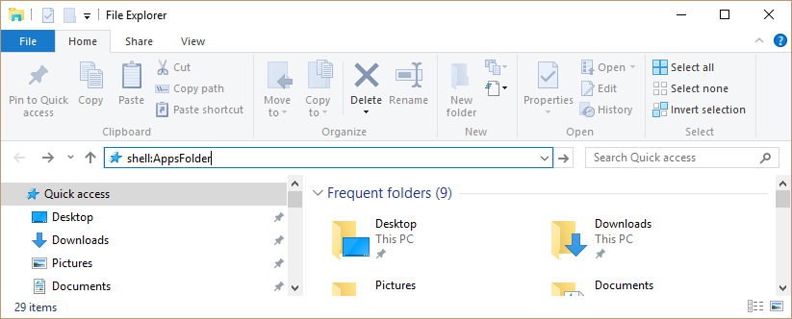

The Explorer will show you all of your installed apps.

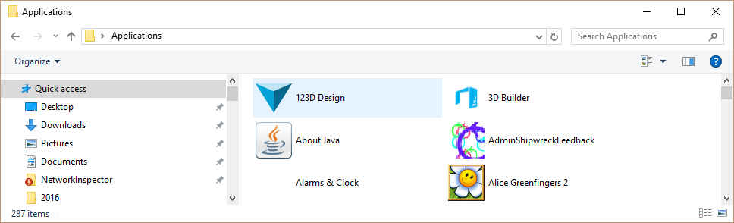

Right-click Best Calculator and select “Create a Shortcut”. You will be told that you can only create a shortcut on the desktop; click “Yes”. A shortcut to Best Calculator will be placed on your desktop.

## Program as the Calculator Button

Windows keyboards often include pre-programmed buttons to launch common applications.

You can program the launch buttons to launch Best Calculators.

Run the Microsoft Mouse and Keyboard Center by pressing the Windows key and typing “Mouse and Keyboard”. The Mouse and Keyboard center program will show up.

In the example, the center is programming a Microsoft Wired Keyboard 600 with a Calculator key. We’re going to program the calculator key to start Best Calculator.

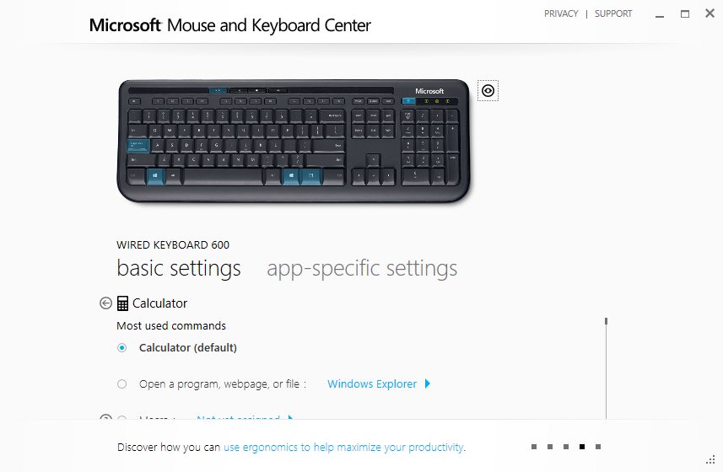

Under the Calculator setting, tap “Open a program, webpage, or file”. Then tap the Windows Explorer button and *carefully* enter

explorer shell:AppsFolder\48425ShipwreckSoftware.BestCalculator_jh2negtepkzpr!App

Then press the back button.

That’s it! The calculator button should now launch the calculator app. If you mis-type the long command line, the Windows Explorer will launch instead.

# !!Heading



Basic Memory operations: get from memory, store into memory

## Get and Store

You are planning on doing a number of calculations using your local tax rate (in the example, 8.25%). You can store the tax rate into memory and then use it later on.

Calculate the tax (8.25%) on three different values (10, 20, and 30)

Key in: 8.25 →M 10 + M→ % =  
Answer: 10.825

Key in: 20 + M→ % =  
Answer: 21.65

Key in: 30 + M→ % =  
Answer: 32.475

The →M key places the current number into memory. The M→ key retrieves the memory value and places it into the display just as if you had typed it.

## Memory Add and Subtract

The M+ key adds the current number to the existing memory value.

The M+ key subtracts the current number to the existing memory value.